 CHEMICAL ENGINEERING TRANSACTIONS  VOL. xxx, 2026 | A publication of  
The Italian Association
of Chemical Engineering
Online at www.cetjournal.it

Guest Editors: Marco Bravi, Antonio Marzocchella, Giuseppe Caputo
Copyright © 2026, AIDIC Servizi S.r.l.
ISBN 979-12-81206-xx-x; ISSN 2283-9216

Improving protein recovery from Limnospira platensis through enzymatic-surfactant synergy
Mariacristina D’Ascoli^{a,}*, Angela Sorrentino^{b}, Antonio L. Langellotti^{b}, Prospero Di Pierro^{a,b}
ªDepartment of Agricultural Sciences, University of Naples Federico II, Piazza Carlo di Bordone, 80055, Portici (NA), Italy.
^{b}Centre for Innovation and Development in Food Industry, University of Naples Federico II, Via Università 133, 80055, Portici (NA), Italy
mariacristina.dascoli@unina.it

By 2050, the global population is expected to reach 9.5 billion, driving a projected 32–78% increase in protein demand and reinforcing the urgency for sustainable, high-quality protein sources in line with the UN Sustainable Development Goals. Since conventional animal-derived proteins impose significant environmental pressures, microalgae represent a sustainable alternative due to their rapid biomass accumulation, low resource inputs and abundance of proteins, polyunsaturated fatty acids and bioactive metabolites. Limnospira platensis (Spirulina) is particularly notable for its elevated protein content, positioning it as a competitive substitute for traditional protein sources such as soy, eggs and meat. However, its structurally resilient cell wall and polysaccharide matrix have necessitated the use of energy-intensive, solvent-based extraction approaches. In this context, lysozyme has emerged as a promising biocatalyst to support greener protein recovery. This study investigated whether lysozyme incubation in the presence of Triton X-100 enhances protein release by mitigating micelle formation. Lyophilized biomass was treated with increasing amount of lysozyme (from 1250 to 5000 U/g of biomass) for 1–2 h, with Triton X-100 maintained at 0.5% (w/v). The optimal condition (2500 U/g) yielded about 30% of protein after 1 h and ∼35% after 2 h with an approximate 24% increase, demonstrating that the synergistic action of lysozyme and surfactant markedly improves cell wall disruption, thus significantly enhancing protein recovery.
  - Introduction
The projected growth of the global population, expected to reach 9.5 billion by 2050, poses a significant challenge to the sustainability of global food systems (Rastegaripour et al., 2024). As the population expands, the demand for essential resources such as arable land and freshwater is expected to rise sharply (Khatri et al., 2024). With this trend, global protein demand for food applications is foreseen to increase substantially, reflecting shifts in dietary needs and consumption patterns. Currently, traditional food production systems, which rely heavily on animal-based protein sources, have become unsustainable being responsible for greenhouse gas emissions and water pollution (Gil et al., 2024).Therefore, finding alternative protein sources has emerged as an urgent topic for the scientific community. The food industry has recently increased its efforts to develop novel products from microalgae biomass for mainstream food production (Cecere et al., 2025). Notably, microalgae protein content typically ranges between 30 % and 55 % of their dry weight, representing a vital resource for high-efficiency protein production, providing also a scalable and sustainable response to the world's protein needs (Zheng et al., 2025). However, expanding component availability is one of the issues that needs to be solved in order to facilitate the broad use of microalgae. Indeed the cell wall hardness not only makes it difficult to release the valuable microalgae components, but also due to these structural features, the use of the entire microalgal biomass limits the access of enzymes in the digestive tract, making it impossible to employ its constituent parts during digestion (Vladic et al., 2025).
Conventional extraction methods are known to be effective in protein extraction, but there’ s a significant concern about their possible environmental impact due to a high energy demand (Jain et al., 2024). Moreover, their limitations include also low stability, altered protein techno-functional properties, inadequate extraction yields and compromised nutritional value. As a result, there is an imperative need to use innovative and environmentally friendly extraction technologies that can overcome the technological limitations of conventional protein extraction methods (D’Ascoli et al., 2025; Hewage et al., 2022). Thus, the idea of green extraction methods, like ultrasonication, microwave, pulsed electric filed, has gained strong support among researchers, as it highlights the importance of reducing solvent use, lowering energy consumption and limiting environmental pollution, all while aiming to achieve the highest possible yield (Chemat et al., 2019). Despite that, the extraction landscape is complicated by the diversity of microalgal species, requiring a customized and species-specific approach to extraction techniques (Venkatachalam et al., 2025; Oliviero et al., 2022). In this context, the enzyme assisted extraction (EAE) emerges as a renewable methodology for extracting bioactive compounds under mild conditions, allowing the extraction and preservation of their bioactivity and nutritional properties. Enzymatic hydrolysis offers a cost-effective method for cell wall disruption and extraction of bioactive compounds, providing high product yields and high-quality recovery. Moreover, the selection of a specific enzyme or enzyme mixture, which can further increase yields, depends on their specificity and selectivity for the target compounds while maintaining their functional properties (Ali et al., 2025). Protein recovery in EAE is challenging because the mild conditions are often insufficient to break the stiff Spirulina envelope, which is made rigid by a polysaccharide matrix containing proteinaceous bonds that prevent intracellular protein release (Le Nguyen Doan et al., 2022). To avoid harsh conditions produced by mechanical pre-treatment on biomass, like freeze-thaw, sonication, high-pressure homogenization, the use of chemical agents could facilitate protein extraction while keeping mild condition as EAE. Triton X-100 is a non-ionic detergent which usually allows protein extraction, especially membrane proteins, which retain their native structure and biological activity, by disrupting the lipid-lipid and lipid-protein interactions (Ratkeviciute et al., 2021). Therefore, the disruptive action of Triton X-100 within the context of EAE could enhance the protein extraction efficiency from the biomass while maintaining mild extraction conditions. This study aimed to investigate the combination of lysozyme and Triton X-100 to improve the solubilization and recovery of protein from Limnospira platensis.
  - Material and Methods
    - Materials
Freeze-dried Limnospira platensis biomass was provided by CAISIAL centre (Portici, Italy). The lysozyme enzyme (lisozina DC E.C. 3.2.1.17) was obtained by Dal Cin (Concorezzo, Monza Brianza, Italy). Triton X-100, K₂HPO₄ and KH₂PO₄ (phosphate salts) of analytical grade were purchased from Sigma Aldrich. The biomass had been stored in the dark at a temperature of 4 °C to preserve its integrity.
    - Biomass analysis
The moisture content of the raw materials was determined by drying to constant mass. The contents of ash, fat, and carbohydrate were analyzed following the AOAC procedures. Protein content was determined by the Kjeldahl method and the protein recovery (%) was calculated by the extracted protein amount over the protein content in the raw dry algae. The fat content was determined by Soxhlet. Spectrophotometric techniques were used to determine the sugar content in Spirulina samples by using phenol-sulfuric acid method (Dubois et al., 1956) with some modifications to measure total sugars.
    - Lysozyme assay and specific activity determination
The enzymatic activity of lysozyme (lysozine DC E.C. 3.2.1.17) was tested by evaluating its hydrolytic capacity on the cell wall of Micrococcus lysodeikticus: the reaction was carried out at 25°C and pH 7, monitoring the reduction in absorbance at 450 nm (OD₄₅₀ nm) of a substrate solution at 0.015%. The enzyme preparation showed a specific activity of ~178 U/g, being 1 U of enzymatic activity defined as the amount of lysozyme able of reducing the absorbance of 0.1 OD₄₅₀ in the above conditions.
    - Enzyme assisted extraction
The lysozyme treatment was conducted with different concentration of enzyme (0, 1250, 2500 and 5000 units per gram of dry biomass (U/g)) incubated in phosphate buffer 0.1M (pH 7, solid:liquid ratio = 1:20) at 37°C and at 2000 rpm in a thermal agitator (mod. ISTHBLCTSN, OHAUS®, Newark, New Jersey, USA), for 1 hour and 2 hours. The effect of Triton X-100 was studied conducting the same trials in the presence of 0.5% (w/v) of detergent (Tavanandi and Raghavarao, 2020).
After the extraction, the suspensions were subjected to centrifugation at 4°C and 10,000 x g for 10 minutes. The protein concentration was determined spectrophotometrically by the Bradford method (Bradford, 1976).
    - Statistical analysis
Data were statistically analyzed using SPSS 30.0 (IBM Corp., NY, USA). Each sample was measured in triplicate, and results are reported as mean ± standard deviation (SD). Depending on the experimental design, multi-factor analyses of variance (ANOVA) were applied to evaluate the effects of the studied variables. Tukey's multiple range test was used to analyze the significance of differences between groups, with a significance level of P < 0.05.

  - Results and discussion
Proximate composition analysis of Limnospira platensis powder (dw%) indicated a high protein content (55.2 ± 0.08%, Table 1), confirming its potential as a protein-rich biomass. Total lipids accounted for 6.08 ± 3.05%, while carbohydrates represented 22.56 ± 3.34%. Mineral content was 9.23±0.02%, reflecting a substantial ash fraction consistent with the naturally high inorganic load of cyanobacterial biomass. After the evaluation of the biomass proximate composition, this was subjected to EAE.
Table 1: Proximate analysis of Limnospira platensis powder (dw %).
Proteins | Lipids | Carbohydrates |  | Ashes
55.2±0.08 | 6.08±3.05 | 22.56±3.34 |  | 9.23±0.02

    - Enzyme assisted extraction
The effect of increasing lysozyme on protein recovery from dried Spirulina was investigated. The results reported in the Figure 1 indicate that lysozyme activity reaches its maximum effect at 2500 U/g of dry microalgae, producing the higher protein yield at both incubation times. Moreover, at 2h of incubation time, 2500 U/g treatment was significantly higher compared to the control and to the sample with1250 U/g, underlining that even the incubation time influenced the solubilization of protein, giving the highest protein yield of the overall trial. However, this value dropped when the lysozyme enzyme concentration increased to 5000 U/g, similarly to what observed for cellulase activity trend reported by (Le Nguyen Doan et al., 2022).

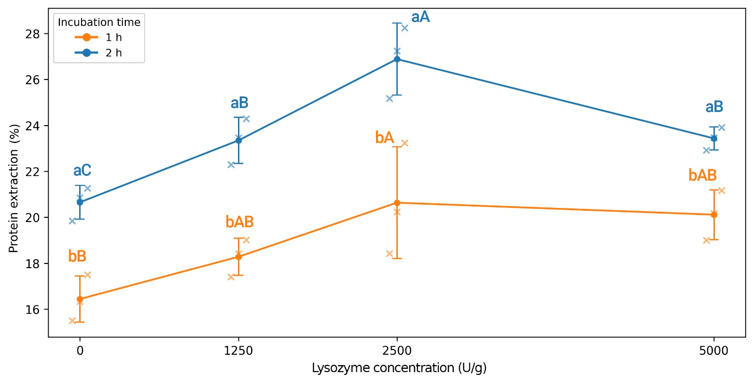

Figure 1: The effect of lysozyme-assisted extraction on protein yield (extracted proteins/g total protein in biomass) for 1h and 2h of incubation. Different lowercase letters represent significant differences between incubation times (1 h vs 2 h) while different uppercase letters represent significant differences among lysozyme concentration levels. (p ≤ 0.05)
Limnospira platensis is a cyanobacteria, where in its cell wall repeated subunits of the aminosugars N-acetylglucosamine and N-acetylmuramic acid are linked through β-1,4 glycosidic linkages producing peptidoglycan (Ragland and Criss, 2017). Lysozyme was selected for the enzymatic extraction due to its specific activity in hydrolyzing this linkage which is abundantly present within the peptidoglycan component of the Spirulina cell wall (Tavanandi and Raghavarao, 2020). Coelho et al., (2020) reported 1.34‐fold increase in protein content using lysozyme treatment compared to control, in line with this experimental trial, with a protein yield of 554 g/kg biomass.
    - Combined enzyme-assisted extraction with Triton X-100
The effect of Triton X-100 with lysozyme treatment on protein recovery has been reported in Figure 2. The presence of a surfactant like Triton X-100 consistently enhanced protein recovery compared to the standard buffer. Notably, at 1 h, the Triton-assisted control without enzyme (0 U/g) reached a yield comparable to that obtained with lysozyme, indicating that the detergent alone substantially improves cell permeabilization and supports overall enzymatic effectiveness. When examining only the Triton X-100 trend, a clear time-dependent improvement is observed. After 2 h of incubation, Triton-assisted extraction produced a markedly higher protein yield compared to the corresponding 2 h control without Triton. From 1250 U/g, the protein recovery increased by approximately 24% relative to the standard-buffer control at the same enzyme level and incubation time. This demonstrates that the synergistic action of Triton X-100 and prolonged lysozyme exposure significantly enhances cell disruption and protein solubilization beyond what is achieved by enzymatic treatment alone. Control treatment in the presence of Triton X gave the same results, but in combination with increasing lysozyme concentration, produced an increasing higher recovery rate.

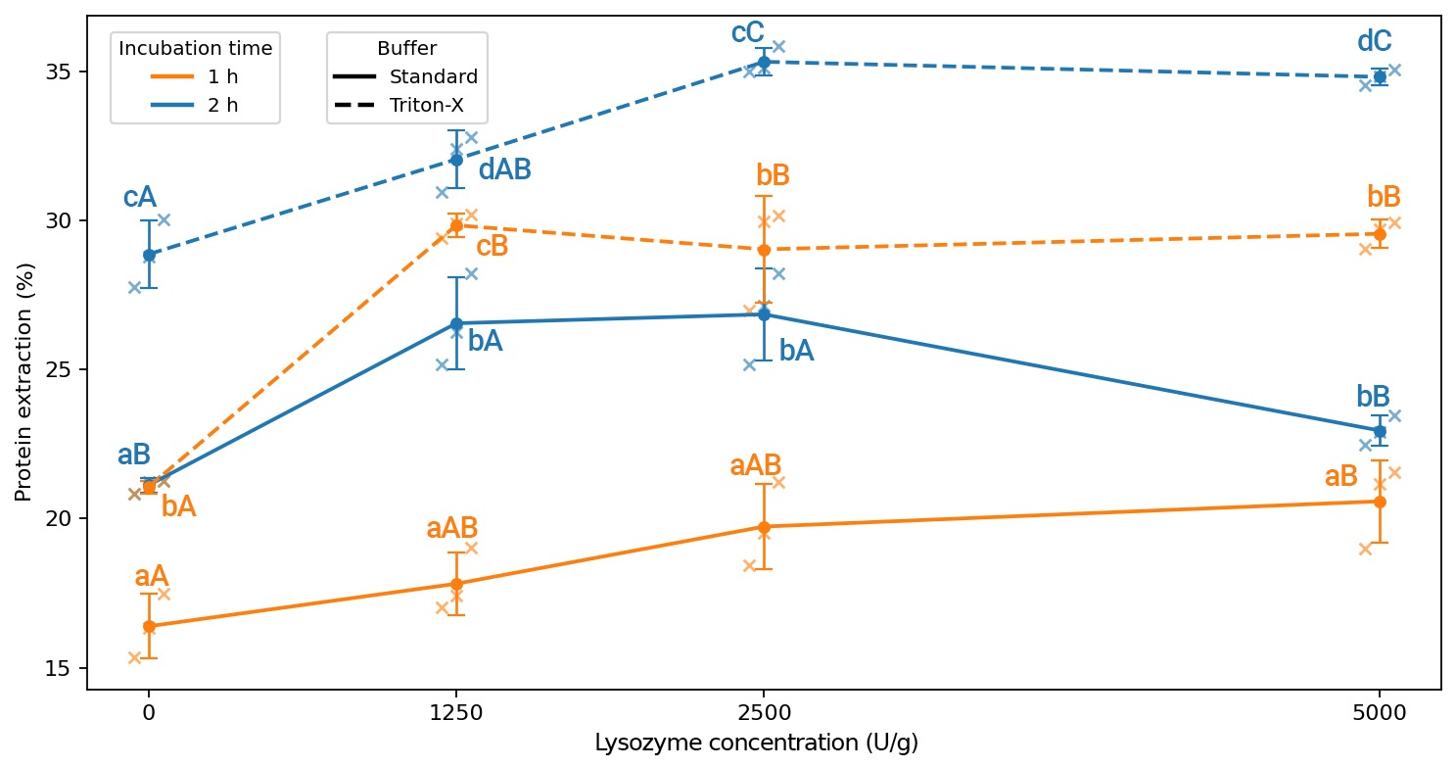
Figure 2: Protein extraction yield (%) as a function of lysozyme activity (U/g; 0 = control) for two extraction buffers (Standard and Triton-X) and two incubation times (1 h and 2 h). Within each buffer at a given lysozyme activity, different lowercase letters represent significant differences between incubation times (1 h vs 2 h). Within each buffer–time combination, different uppercase letters represent significant differences among lysozyme concentration levels.
The presence of Triton X-100 plays a significant role for strand structure which is complexed with certain polysaccharides including cross-linked peptides in L. platensis cell wall. Indeed, this surfactant improves microalgal cell membrane interplay thanks to its strong ability to solubilize membrane proteins (Quintana et al., 2011). In this study the surfactant–enzyme strategy used by Tavanandi & Raghavarao (2020) for phycobiliprotein (C-phycocyanin, C-PC) from Spirulina has been repurposed to recover total protein. In their paper, the authors showed that non-ionic surfactants (Triton X-100, Tween 20, Tween 80) and lysozyme enhance membrane permeabilization and C-PC release, and that surfactant concentration and incubation time strongly affect yield and purity. However, it is worth to notice that the maximal C-PC yield was found at around 1.0% (w/w) of Triton X-100, which was recommended as optimal surfactant-specific. For the experiments reported here, the used concentration of Triton X-100 was fixed at 0.5% (w/v) to reduce spectrophotometric interference and detergent-related artifacts during downstream protein assays. However, Lee et al. (2017) reported that in Chlorella vulgaris the higher amounts of Triton X-100 decrease the protein recovery yields probably to the complex mechanisms taking place during cell dying process, defining optimum concentration at 0.5% (w/v). Thus, in accordance with that, the obtained results show that the addition of lysozyme (2500 U/g) plus 0.5% (w/v) Triton and the increase of incubation from 1 to 2 h raised protein yield by ~24%. This indicates a clear time-dependent synergistic effect under entirely mild, non-mechanical conditions. The presence of Triton X-100 likely enhances membrane permeabilization, improving lysozyme access to the peptidoglycan and polysaccharide-rich outer layers (Yu et al., 2014). In turn, lysozyme progressively hydrolyses structural glycans, enabling the release of intracellular proteins that would otherwise remain inaccessible. Notably, while the previous works allowed to achieve similar improvements using lysozyme in combination with surfactants plus mechanical aids such as ultrasonication, the present results lead to the conclusion that comparable enhancement can be achieved without any physical disruption, but just relying solely on the gentle, combined biochemical action of detergent and enzyme.
  - Conclusions
This study demonstrates that combining lysozyme with low Triton X-100 concentrations enhance enzyme-assisted protein extraction from Limnospira platensis under mild conditions reaching at 2h and 2500U/g 35.41 ± 0.61% protein yield. The detergent increases membrane permeability, allowing lysozyme to more effectively degrade the polysaccharide-rich envelope and release intracellular proteins with time-dependent improvements. However, Triton X-100 is not food-grade and must be removed or replaced with approved surfactants. Detergents may also interfere with protein quantification and co-extract unwanted components, requiring rigorous analytical validation and purification. Thus, while this approach supports green extraction strategies, future work should focus on food-safe surfactants and scalable purification to ensure high-quality proteins for human consumption.

Acknowledgment
The work was supported by the project “Bioscience” -PON03PE_00060_3 financed by European Regional Development Fund (EU-FESR), Italian Ministry of Education, University and Research.

References

Ali, S.S., Al-Tohamy, R., Al-Zahrani, M., Schagerl, M., Kornaros, M., Sun, J., 2025. Advancements and challenges in microalgal protein production: A sustainable alternative to conventional protein sources. Microb. Cell Fact. 24, 1–23.
Bradford, M.M., 1976. A rapid and sensitive method for the quantitation of microgram quantities of protein utilizing the principle of protein-dye binding. Anal. Biochem.
Cecere, G., Sahar, A., Alba, B., Ilija, S., Pere, F. i. P., Rigamonti, L., 2025. Assessing the social risk of high-protein food alternatives using the social life cycle assessment. Food Policy 134, 102894.
Chemat, F., Abert-Vian, M., Fabiano-Tixier, A.S., Strube, J., Uhlenbrock, L., Gunjevic, V., Cravotto, G., 2019. Green extraction of natural products. Origins, current status, and future challenges. TrAC - Trends Anal. Chem. 118, 248–263.
Coelho, D., Lopes, P.A., Cardoso, V., Ponte, P., Brás, J., Madeira, M.S., Alfaia, C.M., Bandarra, N.M., Fontes, C.M.G.A., Prates, J.A.M., 2020. A two-enzyme constituted mixture to improve the degradation of Arthrospira platensis microalga cell wall for monogastric diets. J. Anim. Physiol. Anim. Nutr. (Berl). 104, 1–408.
D’Ascoli, M., Langellotti, A.L., Russo, G.L., Sorrentino, A., Di Pierro, P., 2025. Phycocyanin extraction from Limnospira spp.: sustainable source of natural blue color for the food industry. Curr. Res. Food Sci.
Dubois, M., Gilles, K.A., Hamilton, J.K., Rebers, P.A., Smith, F., 1956. Colorimetric Method for Determination of Sugars and Related Substances. Anal. Chem. 28, 350–356.
Gil, M., Rudy, M., Duma-Kocan, P., Stanisławczyk, R., Krajewska, A., Dziki, D., Hassoon, W.H., 2024. Sustainability of Alternatives to Animal Protein Sources, a Comprehensive Review. Sustain. 16, 1–27.
Hewage, A., Olatunde, O.O., Nimalaratne, C., Malalgoda, M., Aluko, R.E., Bandara, N., 2022. Novel Extraction technologies for developing plant protein ingredients with improved functionality. Trends Food Sci. Technol. 129, 492–511.
Jain, I., Kaur, R., Kumar, A., Paul, M., Singh, N., 2024. Emerging protein sources and novel extraction techniques: a systematic review on sustainable approaches. Int. J. Food Sci. Technol. 59, 6797–6820.
Khatri, P., Kumar, P., Shakya, K.S., Kirlas, M.C., Tiwari, K.K., 2024. Understanding the intertwined nature of rising multiple risks in modern agriculture and food system. Environ. Dev. Sustain. 26, 24107–24150.
Le Nguyen Doan, D., Phan The, D., Le, T.T.H., Nguyen, T.X.Q., Nguyen, D.N., 2022. Protein Extraction from Spirulina Platensis with The Cellulase Enzyme Assistance. J. Tech. Educ. Sci. 17, 25–32.
Lee, S.Y., Show, P.L., Ling, T.C., Chang, J.S., 2017. Single-step disruption and protein recovery from Chlorella vulgaris using ultrasonication and ionic liquid buffer aqueous solutions as extractive solvents. Biochem. Eng. J. 124, 26–35.
Oliviero, M., Langellotti, A.L., Russo, G.L., Baselice, M., Donadio, A., Ritieni, A., Graziani, G., Masi, P., 2022. Use of Different Organic Carbon Sources in Cynara cardunculus Cells: Effects on Biomass Productivity and Secondary Metabolites. Plants.
Quintana, N., Van Der Kooy, F., Van De Rhee, M.D., Voshol, G.P., Verpoorte, R., 2011. Renewable energy from Cyanobacteria: Energy production optimization by metabolic pathway engineering. Appl. Microbiol. Biotechnol. 91, 471–490.
Ragland, S.A., Criss, A.K., 2017. From bacterial killing to immune modulation: Recent insights into the functions of lysozyme. PLoS Pathog. 13, 1–22.
Rastegaripour, F., Tavassoli, A., Babaeian, M., Fernández-Gálvez, J., Caballero-Calvo, A., 2024. Assessing the impacts of climate change on water resource management and crop patterns in Eastern Iran. Agric. Water Manag. 295, 108774.
Ratkeviciute, G., Cooper, B.F., Knowles, T.J., 2021. Methods for the solubilisation of membrane proteins: The micelle-aneous world of membrane protein solubilisation. Biochem. Soc. Trans. 49, 1763–1777.
Tavanandi, H.A., Raghavarao, K.S.M.S., 2020. Ultrasound-assisted enzymatic extraction of natural food colorant C-Phycocyanin from dry biomass of Arthrospira platensis. LWT 118, 108802.
Venkatachalam, S.K., Fareed, M., Duraisamy, N., Lavanya, K., Digala, P., Parthipan, P., Vinayagam, R., Sathishkumar, K., 2025. Cell Wall Disintegration in Microalgae: Implications for Efficient Fucoxanthin Extraction. Waste and Biomass Valorization 1–16.
Vladic, J., Radman, S., Zizak, Z., Besu, I., Jerkovic, I., Speranza, L.G., Hala, A.F., Kovacevic, S., Perreira, H., Gouveia, L., 2025. Clean production of microalgae high-value lipid fraction: Influence of different pretreatments on chemical and cytotoxic profiles of Chlorella vulgaris supercritical extracts and life cycle assessment. J. Clean. Prod. 491, 144823.
Yu, D., Huang, G., Xu, F., Wang, M., Liu, S., Huang, F., 2014. Triton X-100 as an effective surfactant for the isolation and purification of photosystem i from arthrospira platensis. Photosynth. Res. 120, 311–321.
Zheng, J., Geng, J., Li, J., Li, D., Yang, S., Lu, X., Liu, J., Zhang, C., Sun, H., 2025. Harnessing microalgae for protein production: advances, functional properties, and industrial potential. Futur. Foods 12, 100776.

